2

Inside the Web Tier
This chapter describes the physical and logical aspects of designing and utilizing a web tier for your applications. It discusses the close relationship that exists between the architectural tiers and the responsibilities that each play in the overall application. Special focus will be given to the web tier, which allows an application to communicate and interoperate with clients over the web.
The Struts framework is based on the Java Servlet Technology and to a lesser extent, JavaServer Pages, and therefore is dependent on a web container. For Struts developers, understanding how the web container processes client requests is fundamental to having a deeper understanding of the framework itself. This chapter illustrates the various components that are part of the web container and what each component’s responsibilities are.

An Architecture Overview
This section presents a high-level architecture view for a Struts application. Although this section shows an architecture for an enterprise application, not all applications written using Struts will be of this size and makeup. However, this type of application does allow us to present many facets of how Struts applications may be configured.
Many applications, and J2EE application especially, can be described in terms of their tiers. The application’s functionality is separated across these tiers, or functional layers, to provide separation of responsibility, reuse, improved scalability, and many other benefits. The separation of tiers may be a physical separation, where each one is located on a separate hardware resource, or the separation may be purely logical. In this case, one or more tiers are collocated on the same hardware resource, and the separation exists in terms of software. Figure 2-1 illustrates the tiers that may be used by a typical Struts application.
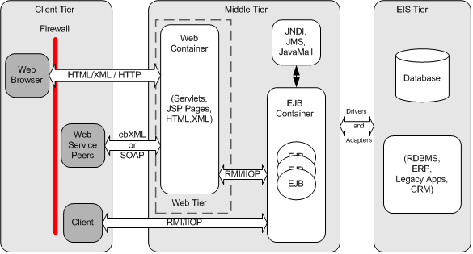
Figure 2-1. Functional Application Tiers
Not every Struts application will contain all of the tiers illustrated in Figure 2-1. For many smaller applications, the Middle tier may consist primarily of a web container that interacts directly with a database in the Enterprise Information Systems (EIS) tier.

The Client Tier
What is a Container?
There are many different types of containers. There are EJB Containers, Web Containers, servlet containers, and so on. In general, containers provide a hosting environment for software components to run in. Containers provide general services that can be used by the components within the environment, without the need or worry of being required by the component developer. A Web Container allows servlets, JSP components, and other Java classes to be deployed and executed within the container. Services like JNDI, connection pooling, and transaction services, can be configured at the container level, and the component developers don’t have to worry about the management of these resources; similar to the way in which EJB containers manages security, transactions, and bean pooling.
When using the services provided by a container, component developers may have to give up some control of the environment to the container, in trade for important services that the developers don’t have to worry about building. Third-party vendors, who must follow certain guidelines that are explicitly laid out in public specifications, build these containers. Although each vendor is allowed to implement certain portions of the container in a proprietary manner, they must follow the specification to ensure that portability can be achieved by the developer.
The Client tier provides a means for a user to interact with the application. This interaction may be through a web browser, or it could also be programmatic through a web services interface. Regardless of the type of client, the interaction includes submitting a request and receiving some type of response from the Middle tier.
In the case of the Struts framework, the most common type of client is a web browser. However, it is also possible to have clients like wireless devices and Java Applets.

The Web Tier
Figure 2-1 shows the Middle tier as an aggregate of the Web tier plus some type of application server component. In the case of Figure 2-1, an EJB container is shown. These two tiers are often combined and many application servers include Web tier functionality.
The Web tier provides the ability for the client tier to communicate and interact with application logic that resides in other tiers. In more traditional web applications, it’s not uncommon for some or all of the application logic to reside in this tier. In larger, enterprise-scale applications, the Web tier acts as a translator and maps HTTP requests into service invocations on the Middle tier.
The Web tier is also responsible for managing screen flow based on application and user state. The Web tier communicates with either a database, or in the case of an enterprise application, an application server. The Web Tier is the glue that binds client applications to the core backend business systems.
The components that reside in the Web tier allow developers to extend the basic functionality of a web service. In the case of Struts, it does this by utilizing framework components that run in a servlet container.

The Middle Tier
The Middle tier is often referred as the “application tier” or “server”. This is due in part to the fact that there is often an application server within this tier. Not all Struts applications have an application tier. This is especially true for small web applications. Many small projects choose to forgo using a large application server and communicate directly with a database or some other data store. When an application server is present, the Web tier communicates to it using some variation of RMI. In the case where an EJB server is present in the application tier, the communication protocol is RMI over IIOP.
RMI Over IIOP
Remote Method Invocation (RMI) allows methods to be invoked on remote objects. Java’s implementation of RMI is known as Java Method Remote Protocol (JRMP) has been around for quite some time and is specifically designed for Java-to-Java remote communications.
One of the issues with Java’s version of RMI is that a JVM must be running on both the client and server for it to be used. With the number of so-called legacy applications that are written in languages such as C++, Java needed a way to communicate with these systems. This is where RMI over IIOP helps out.
Internet Interoperability Protocol (IIOP) was designed to allow distributed components to communicate with one another using TCP/IP. IIOP is language and platform independent.
So, by using RMI on top of IIOP, Java can communicate with applications written in many other different languages and on various platforms. RMI/IIOP as it is often written, is required for all EJB servers to support and exists in the EJB and J2EE specifications.
When included, the application tier might provide a more scalable, fault tolerant, and highly available architecture. This of course, depends on many different factors. One of the main purposes of using an application tier is to separate the responsibilities of presentation from that of the model and the business rules for the application. Today, many web applications are using EJB servers for their application tier. They may not be utilizing all aspects of the J2EE architecture, like EJBs, but there are other benefits that can be leveraged from a J2EE server.

The Enterprise Information System Tier (EIS)
The Enterprise Information System (EIS) tier contains data and services that are used throughout the enterprise. It provides access to enterprise resource such as databases, mainframes, Customer Relationship Management (CRM) applications, and resource planning systems.
The middle tier communicates with components in the EIS tier using protocols that are specific to that resource. For example, to communicate with a relational database, the Middle tier will normally use a JDBC driver. For Enterprise Resource Planning (ERP) systems, a proprietary adapter is used, although some ERP systems and other enterprise resources are starting to support a more web service-like access approach.

Where does Struts Fit In?
After briefly examining these different tiers, it’s important to understand which tier the Struts framework exists in. As illustrated in Figure 2-2, the Struts framework resides in the Web Tier.
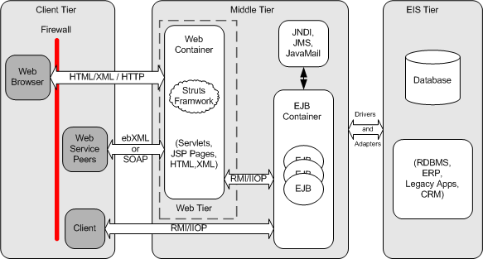
Figure 2-2. The Struts framework is used within the Web Tier
Struts applications are hosted by a web container and can make use of services provided by the container, like handling requests via the HTTP and HTTPS protocol. This frees developers up to focus on building applications that solve a business problem.

The HTTP Request/Response Phase
To better understand how the web server and servlet container work together to service clients, this section discusses the protocol for a HTTP request and response, from the time a client request is received until the server returns a response. This discussion is necessary because Struts makes heavy use of the request and response objects throughout the framework and a thorough understanding of the round-trip process will help to make things more clear for discussions later in the book.
Although the browser is only one possible type of client that can be used with Struts, it is certainly the most common. More and more developers are starting to use Struts for wireless applications and even some interaction with web services, however the web browser remains the prominent client.
There are two types of HTTP messages, the request and the response. HTTP is based on a request/response model. The browser opens a connection to a server and makes a request. The server processes the client’s request and returns a response. Figure 2-3 illustrates this process.
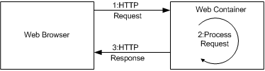
Figure 2-3. The HTTP request/response model
Both types of messages consist of a start line, zero or more header fields, and an empty line, which indicates the end of the message headers. Both message types may also contain an optional message body.
The format and makeup of the request and response messages are very similar, but there are a few differences. We’ll discuss each one separately.

The HTTP Request
The start line of an HTTP request is known as the Request-Line. It’s always the first line of the request message and it contains three separate fields:
- An HTTP method
- A Universal Resource Identifier (URI)
- An HTTP Protocol Version
Although there are several HTTP methods for retrieving data from a server, the two used most often are GET and POST. The GET method requests a specified resource from the server, indicated by the request URI. If the URI is a data producing resource, like a servlet, the data will be returned within the response message. Although the GET message can pass information in the query string, the POST method is used to explicitly pass data to the server that can be used for processing by the request URI.
The Universal Resource Identifier (URI) identifies the resource that should process the request. For the purposes of this discussion, it can either be an absolute path or a relative one. A request with an invalid URI will return an error code, typically a 404.
The HTTP request protocol version is simply an identifier to the server of which version of the HTTP specification the request conforms to. The following example illustrates the request line for a sample GET request.
GET /index.html HTTP/1.0
You can actually execute this example by opening up a telnet session to a server running a web server. You must specify the host name and port number of the web server, such as:
telnet localhost 80
You can then type the GET command. You will need to press enter twice after issuing the command; once for the end of the request line and then the other return is to let the server know you are finished with the request. Assuming there’s a file called index.html in the root directory, you will see the HTML response returned. Actually, you will always see a response. It just may not be the one that you expected. We’ll talk more about using the telnet application to interact with a web server when we discuss redirects and forwards later in this chapter.
As mentioned, the HTTP request may also contain zero or more header fields. Request header fields allow the client to pass additional information about the request and also the client itself, to the server. The format of a header field, for request and responses, is the name of the header field, following by a colon “:” and the value. If multiple values are specified for a single header field, they must be comma-separated. Table 2-1 shows some of the more commonly used request headers.
Table 2-1. Common HTTP Request header fields
Name Purpose
Accept Used to indicate the media types, which are acceptable for the response. If no Accept header field is present, the server can safely assume that the client accepts all media types. An example of an Accept header value is “image/gif, image/jpeg”.
Accept-Charset Used to indicate what character sets are acceptable for the response. If the Accept-Charset header is not present in the request, the server can assume that any character set is acceptable. The ISO-8859-1 character set can be assumed to be acceptable by all user agents.
Accept-Encoding This header is very similar to the Accept header field, except that it further restricts the content-coding values, which are acceptable by the client. An example of an Accept-Encoding header value is “compress, gzip”.
Accept-Language Used to indicate which languages the client would prefer to have the response in. An example of an Accept-Language header value is “en-us, de-li, es-us”.
Content-Encoding It helps indicate what encoding mechanism has been applied to the body of the message and therefore what decoding must be used to get the information. An example of a Content-Encoding header value is “gzip”.
Content-Type Used to indicate the media type of the body sent to the recipient. An example of a Content-Type header is “text/html; charset=ISO-8859-1”.
Host Used to indicate the host and port number of the resource being requested, as obtained from the original URL. An example of the Host request header is “www.somehost.com”.
Referer The Referer request header field allows the client to specify the address (URI) of the resource from which the request URI was obtained. It is mainly used for maintenance and tracking purposes.
User-Agent The User-Agent request header field contains information about the client that originated the request. It’s mainly used for statistical purposes and tracing of protocol violations. An example of a User-Agent is “Mozilla/4.0 (compatible; MSIE 6.0; Windows NT 5.0)”.
The message body for a request is used to carry data that is associated with the request to the server. The data that is included within the body is different from the values used by the header fields both in terms of format and content. The header fields can be viewed as meta-data about the message body.

The HTTP Response
Once the server has received and processed the request, it must return an HTTP response message back to the client. The response message consists of a status line, zero or more header fields, followed by an empty line. It may also have an optional message body, similar to the request message.
The first line of the HTTP response message is known as the status line. It consists of the HTTP protocol version that the response conforms to, followed by a numeric status code and its textual explanation. Each field is separated by a space. An example response status line is shown here:
HTTP/1.1 200 OK
The status code is a 3 digit numeric value that corresponds to the result code of the server’s attempt to satisfy the request. The status code is for programmatic applications, while the reason text is intended for human readers. The first digit of the status code defines the category of the resulting code. Table 2-2 provides the allowed first digits and the corresponding category.
Table 2-2.Status Code Categories
Numeric Value Meaning
100-199 Informational – Request has been received, continuing to process it.
200-299 Success – The action was successfully received, understood, and accepted.
300-399 Redirection – Further action must be taken in order to complete the request.
400-499 Client Error – The request contains bad syntax or cannot be fulfilled.
500-599 Server Error – The server failed to fulfill an apparently valid request.
There are quite a few status codes that have been defined. They are also extensible, which allows applications to extend the behavior of the server. If a client application doesn’t recognize a status code that has been returned by the server, it can assume the type of response status by using the first digit of the returned status code. Table 2-3 lists some of the most common response status codes.
Table 2-3. Common HTTP Response Status Codes
Code Meaning
200 OK—The request has succeeded.
302 Moved Temporarily —The request resides temporarily under a different URI. If the new URI is a location, the location header field in the response will give the new URL. This is typically used when the client is being redirected.
400 Bad Request—The server couldn’t understand the request due to malformed syntax.
401 Unauthorized—The request requires authentication and/or authorization.
403 Forbidden—The server understood the request, but for some reason is refusing to fulfill it. The server may or may not reveal why it has refused the request.
404 Not Found—The server has not found anything matching the request URI.
500 Internal Server Error—The server encountered an unexpected condition which prevented it from fulfilling the request.
The header fields in the response are similar in format to those found in the request message. They allow the server to pass additional information to the client, which cannot be placed in the status line. These fields give information about the server and about further access to the URI contained within the request. After the last response header, which is followed by an empty line, the server can insert the response message body. In many cases, the response message body is HTML output. Figure 2-4 illustrates an example response:
GET /hello.html HTTP/1.0
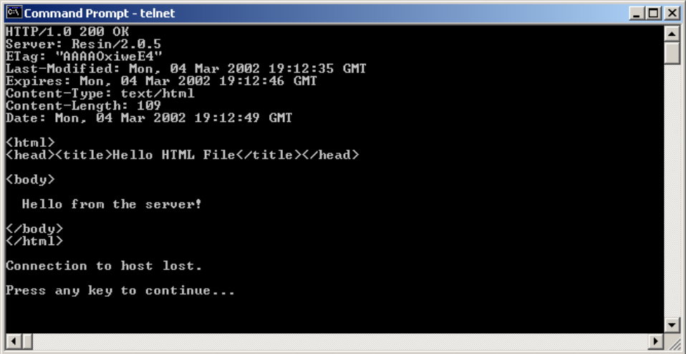
Figure 2-4. An example HTTP response message

HTTP versus HTTPS
You’ve obviously noticed that the request and response message text shown in the previous examples have all been standard readable text. This is fine for some cases, however it also means that computer hackers can as well. When you need to ensure the integrity and privacy of information that is sent over a network, especially an open one like the Internet, one of the options is to use the HTTPS protocol, rather than standard HTTP.
HTTPS is normal HTTP wrapped by a Secure Sockets Layer (SSL). SSL is a communication system that ensures privacy when communicating with other SSL-enabled applications. It’s really just a protocol that runs on top of the TCP/IP layer. It encrypts the data through the use of symmetric encryption and digital certificates. An SSL connection can only be established between a client and server when both systems are running in SSL mode and are able to authenticate each other.
The fact that the SSL layer encrypts the transmitted data has no impact on the underlying request and response message. The encryption and subsequent decryption on the other side occurs after the message is constructed and is decoupled from the HTTP portion of the message.
Chapter 14 deals with security in a Struts application. HTTPS and SSL will be covered more thoroughly there.

Struts and Scope
The Struts framework utilizes various shared resource areas to store objects. The shared resource areas all have a lifetime and visibility rule that defines the scope of the resource. This section discusses these resources, their scopes, and how the framework utilizes them.

Request Scope
Each time a client issues an HTTP request, the server creates an object that implements the javax.servlet.http.HttpServletRequest interface. Among other things, this object contains a collection of key/value attribute pairs that can be used to store objects for the lifetime of the request. The key of each pair is a String and the value can be any type of Object. The methods to store and retrieve objects into and out of the Request scope are:
public void setAttribute( String name, Object obj );
public Object getAttribute( String name );
Request-scope attributes can be removed using the removeAttribute() method, however, because the scope of the attribute is only for the lifetime of the request, it is not as important to remove them as it is for other request-scope attributes. Once the server fulfills a request and a response is returned to the client, the request, and therefore the attributes are no longer available to the client and may be garbage collected by the JVM.
The Struts framework provides the ability to store JavaBeans into the request, so that they can be used by presentation components like JSP pages. This makes it much easier to get access to JavaBeans data, without having to do manual cleanup of removing the objects later. The web container will take care of it for you. There’s seldom a need to remove objects from request scope. As you can see, the visibility of objects stored at the request level is only for resources that have access to that request. Once the response has been returned to the client, the visibility is gone. Objects that are stored in one request are not visible to any other client request.

Session Scope
The next higher level of visibility is session scope. The web container will create an object that implements the javax.servlet.http.HttpSession interface to identify a user across multiple page requests. The user’s session will persist for a period of time that is based on how frequent the user makes a request. This allowed inactivity time is configurable through the application deployment descriptor. It may also be prematurely destroyed by calling the invalidate() method on the session object.
The session also allows for a collection of objects to be stored based on a key/value pair schema, similar to the request object. The only difference between this one and the one provided by the request is the duration of the objects. Since sessions exist across multiple requests, objects stored in the session scope live longer than those at the request level. The Struts framework uses session attributes quite extensively. An example of an object that may be stored as a session attribute is the Locale object for the user. This allows the entire framework access to the user’s locale to perform localized behavior. Objects stored in one user’s session are not visible to users with a different session.
There is no synchronization provided by container for the session object. If multiple threads attempt to access an object stored in the session and modify the value, it’s up to the developer to provide synchronization. There is no automatic synchronization provided by the session. Although the need to synchronize access to the session is quite low, you must realize that the developer has the responsibility to protect the resources. Scenarios where multiple threads might access the session at the same are if your application uses frames, or if you have a process takes a long time to complete. Both of these situations could cause more than one thread to attempt to access the same session attribute.

Application Scope
An even higher level of visibility and duration comes with objects stored at the application scope level. These are objects that are visible to all client and threads of the current web application. They live until they are programmatically removed or until the application is terminated.
The server creates an object that implements the javax.servlet.ServletContext interface for each and every web application that is installed within the container. The ServletContext object allows objects to be stored and retrieved exactly like they are done for the request and session scopes, with the one difference being that the objects are visible to the entire application and persist for the lifetime of the application. The Struts framework uses application scope to store JavaBeans that need to be visible to all users. Normally, objects are stored in this scope during application startup and remain there until the application exits.

Page Scope
The last scope to discuss has to do exclusively with JSP pages and is referred to as page scope. Objects with page scope are only accessible within the JSP page that they are created. Once the response is sent to the client or the page forwards to another resource, the objects are no longer available. The objects are stored in the javax.servlet.jsp.PageContext object for each page.
Every JSP page has an implicit object reference named pageContext that can be used to store and retrieve page-level objects. It includes the same getAttribute() and setAttribute() methods that the other scopes offer and function in the same manner.

Using URL Parameters
Request* parameters are strings that are sent with the client request to the server. The parameters are inserted into the HttpServletRequest object from the URI query string and data that is sent in a POST method. The parameters are formatted as key/value pairs.
URL parameters are only available via the getParameter() method when a POST method is used. If the HTTP method is a GET, the only way the server can gain access to the parameters included in the query string is by parsing the String returned from the getPathInfo() or getRequestURI() methods.
URL parameters play an important role in all web applications and the Struts framework is no exception.

Forward versus Redirect
It’s often necessary to share control of a request by more than a single component. One servlet may be responsible for authenticating and authorizing a client, while it’s the job of a different servlet to retrieve some data for the user. This sharing of control of a request is accomplished in several different ways. Two of which, we want to discuss in this section.
There are several important differences between how a web container processes a forward request versus a redirect. Since the Struts front controller servlet, which was discussed in Chapter 1, will always perform one or the other for a typical request, it’s important that you understand these differences and the impact that each mechanism will have on your application.

How a Redirect Works
When a sendRedirect() method is invoked, it causes the web container to return a response back to the browser with information that a new URL should be requested. Because the browser issues a completely new request, any objects that are stored as request attributes before the redirect occurs, will be lost. This is one of the biggest differences between a forward and redirect. Figure 2-5 illustrates why this occurs.
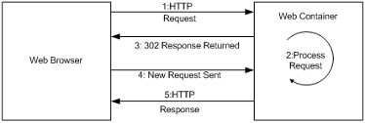
Figure 2-5.A redirect causes the browser to issue a new request
Because of the extra round-trip that occurs, a redirect is slower than using a forward. Example 2-1 provides an example servlet that performs a redirect for a JSP page called result.jsp, when a request is issued for the servlet.
Example 2-1. A Java servlet that performs a redirect when it receives a request

package com.oreilly.struts.chapter2examples;

import java.io.IOException;
import javax.servlet.ServletException;
import javax.servlet.http.HttpServlet;
import javax.servlet.http.HttpServletRequest;
import javax.servlet.http.HttpServletResponse;
import javax.servlet.RequestDispatcher;

/**
* Perform a redirect for the page "redirect.jsp"
*/
public class RedirectServlet extends HttpServlet {

public void doGet(HttpServletRequest request, HttpServletResponse response)
throws ServletException, IOException{
redirect( request, response );
}

public void doPost(HttpServletRequest request, HttpServletResponse response)
throws ServletException, IOException{
redirect( request, response );
}
/**
* Set a few URL parameters and objects for the request to see what happens
* to them during a redirect.
*/
protected void redirect(HttpServletRequest req,HttpServletResponse resp)
throws ServletException, IOException{
log( "A request arrived for " + req.getServletPath() );

// Put some objects into request scope
req.setAttribute( "firstName", "John" );
req.setAttribute( "lastName", "Doe" );

String contextPath = req.getContextPath();
String redirectStr = contextPath + "/result.jsp?username=foo&password=bar";

log( "redirecting to " + redirectStr );

// Always call the encodeRedirectURL method when perfoming a redirect
resp.sendRedirect( resp.encodeRedirectURL(redirectStr) );
}
}
When the servlet in example 2-1 receives either a GET or POST request, it calls the redirect() method and passes the HTTPServletRequest and HTTPServletResponse objects to it. The method sets two String objects into the request so that it can be demonstrated that they will not be available after the redirect. It creates a String that will become the URL that the client is told to make a new request for. After the encodeRedirectURL() method is called and passed the redirect string, the sendRedirect() method is invoked on the response object.
All URLs passed to the sendRedirect() method should be ran through the encodeRedirectURL() method so that the Session ID can be included if the browser doesn’t support cookies and session tracking needs to occur. The Struts framework performs this step automatically in the RequestProcesser during normally action processing.
The JSP page that the servlet will redirect to is shown is example 2-2.
Example 2-2. A simple JSP page that a client is redirected to when calling the RedirectServlet from example 2-1
<html>
<head>
<title>Struts Redirect/Forward Example</title>
</head>

<body>
<img src="images\tomcat-power.gif">
<br>
<%
String firstName = (String)request.getAttribute( "firstName" );
if ( firstName == null ){
firstName = "Not found in request";
}

String lastName = (String)request.getAttribute( "lastName" );
if ( lastName == null ){
lastName = "Not found in request";
}
%>

<b>First Name:</b> <%=firstName%><br>
<b>Last Name:</b> <%=lastName%><br>

</body>
</html>
When you enter the URL for this servlet in a browser:
http://localhost:8080/servlet/com.oreilly.struts.chapter2examples.RedirectServlet
The browser output will look like the one in Figure 2-6.
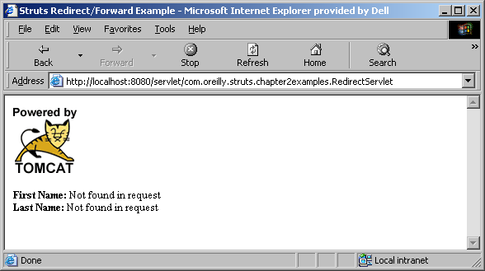
Figure 2-6. The output page when the RedirectServlet is called
You’ll notice that the first name and last name arguments that were set in the servlet were not found in the request. This is because a second request was actually issued for this page. Fortunately, we can peek behind the scenes and observe what’s taking place.
Let’s look at the HTTP response that comes back to the client when the RedirectServlet is requested. We can see this using a standard telnet session. Since an HTTP connection uses a simple network socket to communicate with the server, we can partially simulate the interaction between a browser and a server using the telnet application. You can establish a connection to a web server using telnet by connecting to the port that the server is listening on, usually port 80 or in the case of Tomcat 8080.
telnet localhost 8080
You can do this from the command line, whether you’re using a DOS shell or Unix. The telnet session will alert you if it’s unable to connect to a server with the hostname and port.
If a connection is established, the telnet session will sit and wait for you to enter the HTTP request information. The only information that you are required to enter is the first line of the request, which tells the server what resource the client wants. Each line in the request is a text line, separated by a newline character. The request header ends with a blank line, so you actually have to press “enter” twice to let telnet know you are done with the request. Figure 2-7 shows the HTTP response message returned from Tomcat when a request is made for the RedirectServlet resource.
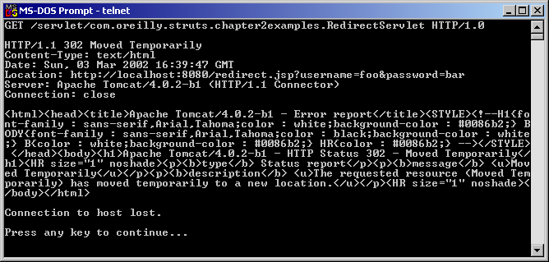
Figure 2-7. You can use a telnet session to inspect the HTTP response headers
In Figure 2-7, the first line of the request issues a GET and a path for a resource. The path is the portion of the HTTP request that comes after the host name and includes the preceding “/” character. The “HTTP/1.0” string at the end of the GET request is the HTTP version protocol.
HTTP version 1.1 added a number of optimizations over 1.0. However, there are additional request headers that must be included, which would make this example more complicated than necessary. Therefore, 1.0 was used to issue the request.
Everything after the first line is a response from the server. The entire HTML output at the bottom comes from Tomcat. It informs anyone that is interested that the original request has performed a redirect and the client should request a new URL.
If you look at the Location response header, which is five lines down in Figure 2-7, you can see that the server has informed the client what the URL should be for the new request. Any URL parameters that were attached to the original request will still be present in the new request. You can see this by looking at the value of the Location response header in Figure 2.7. When the browser issues the new request, these parameters will be sent.
The technique of using telnet provides a simple way of interacting with a web server and viewing what responses it sends back to the client.
Hopefully, you now have a better understanding of how a redirect works. It should also be clearer why any objects placed into the original request are not available to the redirected resource. This will become very important later when we discuss the Struts framework.
One interesting thing may not catch your attention here. Notice back in example 2-1, the redirect string didn’t explicitly contain the hostname and port that the client needed to use for the new request. It’s the job of the servlet container to translate the relative URL to a fully qualified URL for transmission back to the client. Later in the Chapter 20, you’ll see a way of overriding this behavior. This may be necessary if you’re using a proxy server and masquerading the server on another host or port.

Using a Forward
A forward differs from a redirect is several distinct ways. For one, when you invoke a forward for a request, the request is sent to another resource on the server, without informing the client that a different resource is going to process the request. This process occurs completely within the web container and the client is never the wiser. Unlike a redirect, objects can be stored into the request and passed along for the next resource to make use of. Figure 2-8 illustrates the steps that take place when a request is forwarded.
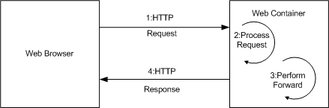
Figure 2-8. During a forward, the request is sent to a secondary resource on the server without notifying the client
Since a forward takes place completely on the server and there is no communication with the client, the performance is better than a redirect. However, there are some differences in how a forward deals with relative URLs. Example 2-3 should make this clearer.
Example 2-3. A Java servlet that performs a forward when it receives a request
package com.oreilly.struts.chapter2examples;

import java.io.IOException;
import javax.servlet.ServletException;
import javax.servlet.http.HttpServlet;
import javax.servlet.http.HttpServletRequest;
import javax.servlet.http.HttpServletResponse;
import javax.servlet.RequestDispatcher;
/**
* Perform a forward to the page "redirect.jsp"
*/
public class ForwardServlet extends HttpServlet {

public void doGet(HttpServletRequest request, HttpServletResponse response)
throws ServletException, IOException{
forward( request, response );
}

public void doPost(HttpServletRequest request, HttpServletResponse response)
throws ServletException, IOException{
forward( request, response );
}
/**
* Set a few URL parameters and objects for the request to see what happens
* to them during a redirect.
*/
protected void forward(HttpServletRequest req, HttpServletResponse resp)
throws ServletException, IOException{
log( "A request arrived for " + req.getServletPath() );

// Put some objects into request scope
req.setAttribute( "firstName", "John" );
req.setAttribute( "lastName", "Doe" );

String redirectStr = "/result.jsp?username=foo&password=bar";

this.log( "forwarding to " + redirectStr );
RequestDispatcher dispatcher = req.getRequestDispatcher( redirectStr );
dispatcher.forward( req, resp );
}
}
When the servlet in example 2-3 receives either a GET or POST request, it calls the forward() method and passes the HTTPServletRequest and HTTPServletResponse objects to it. As with the redirect example, two String objects are set into the request. However, in contrast with the redirect example, the objects will be available after the forward. It next creates a redirect path that the request will be passed to. A RequestDispatcher is created and the forward() method is invoked on it. We’ll use the same JSP page from example 2-2. In the browser, we enter a URL like:
http://localhost:8080/servlet/com.oreilly.struts.chapter2examples.ForwardServlet
and the browser output should look similar to Figure 2-9.
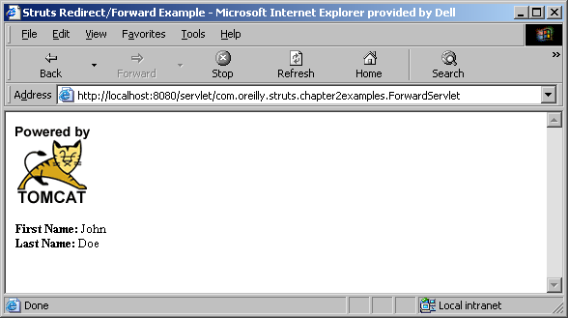
Figure 2-9. The output page when the ForwardServlet is called
There are two interesting items that can be seen from Figure 2-9. The first is that the first and last name fields have values. This is because the objects were placed into the request before the forward occurred and the result.jsp was able to retrieve the values and use them in the page.
The second interesting item is the URL in the address bar. Notice that the URL back in Figure 2-6 showed the new URL that the client requested, whereas it didn’t change in Figure 2-9. This shows further that the client is not aware that a forward occurred. It didn’t get a notice that the browser URL should change.
The forward method of the RequestDispatcher class can only be called when output hasn’t already been committed to the client. Writing something to the response object and then calling forward will result in an IllegalStateException being thrown by the container.

Which one for Struts?
It’s difficult to decree whether you should use a redirect or a forward for Struts applications, since we haven’t discussed the framework yet. However, there are some key points about using each approach. Both mechanisms have their pros and cons within Struts and web applications in general. For many situations, a forwarded is recommended over a redirect. This is chiefly due to the fact that when a forward is used, objects that are stored in the request scope, are easily available to the presentation components. In fact, using a forward is the default case for the Struts framework. Another advantage of a forward is that it’s must more efficient, since the client is not required to issue a new request.
There are however, some situations where a redirect is necessary or preferred over using a forward. The problem revolves around the fact that when forwards are used, the URL’s are not always keep consistent with the state of the client application. If the browser’s refresh button is pressed, unexpected results can occur. This may not make too much sense right now, but it will be explored further in Chapter 5.
[Editors: I wanted to mention something in here about HttpSession management, but I wasn’t sure if it belonged in here or say in the design chapter. Any feedback on this question would be helpful.]

* URL parameters are often referred to as query or request parameters.

